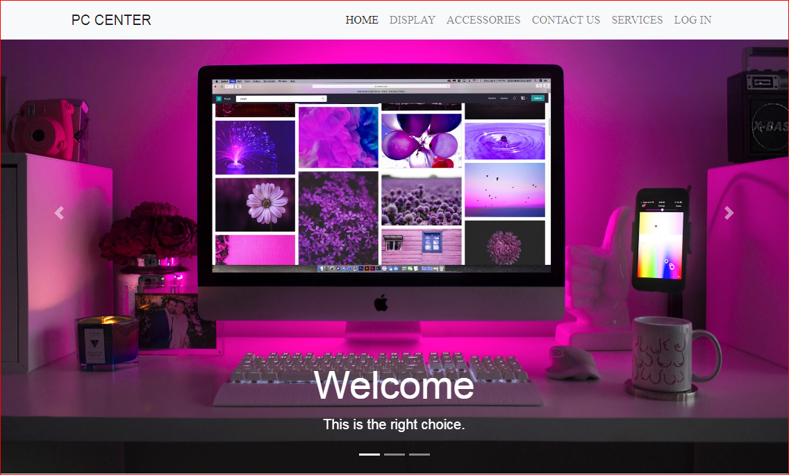

# E - Project User Guide

# Faculty : Sir Tufail Khan

# Batch Co-ordinator : Kiran Nadeem

# Batch Code : 1901B1

**PC CENTER**

**GROUP MEMBER,S**

**Muhammad Husnain**

[**Hasnainm206@gmail.com**](mailto:Hasnainm206@gmail.com)

**Student Id :** **1166828**

**Daniyal Khan**

[**Dk720820@gmail.com**](mailto:Dk720820@gmail.com)

**Student Id :** **1168447**

**Muhammad Moin**

[**Moinsahab718@gmail.com**](mailto:Moinsahab718@gmail.com)

**Student Id : 1166953**

**Project Group Members**

Muhammad Husnain

[**Hasnainm206@gmail.com**](mailto:Hasnainm206@gmail.com)

Student Id :

Daniyal Khan

[**Dk720820@gmail.com**](mailto:Dk720820@gmail.com)

Student Id :

Muhammad Moin

[**Moinsahab718@gmail.com**](mailto:Moinsahab718@gmail.com)

**Student Id : 1166953**

**Contents**

* **HOME**
* **DISPLAY**
* **ACCESSORIE**
* **PRODUCTS**
* **LAPTOPS**
* **APPLE**
* **DELL**
* **HP**
* **DESKTOP**
* **HP**
* **DELL**
* **ACER**
* **MONITER,S**
* **LED**
* **SAMSUNG**
* **APPLE**
* **MOUSE**
* **KEYBORDS**
* **CONTACT US**
* **SERVICES**
* **LOG IN**
* **REGISTRATION FORM**

**INTRODUCTION**

With a grateful heart, I want to thank almighty ALLAH and all those who have helped me in making this project a success,

This was our Opportunity Project that we all made together.

**PC CENTER** will be a whole sale center whose main product will be to provide all the latest model computers, laptops, and all the accessories related to them. This center will also deal in all the branded desktop computers and laptops. This center will also provide all the original software like windows, office, antivirus, games, media players and many more.

**“THANK YOU SO MUCH FOR THE APTECH COMPUTER CENTER WHICH HAVE GIVEN US A PROJECT”**

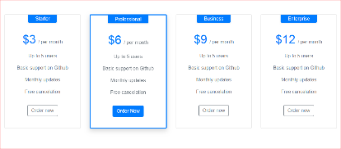

**The home page is the name of the main page of a website where visitors can find hyperlinks to other pages on the site**

HOME

DISPLAY

ACCESSORIE

PRODUCTS

CONTACT US

SERVICES

REGISTRATION FORM

Find us

Quick link

Follows

**Discover top deals PC Center , things to do & more Check back every day for new deals near you Buying is fast, easy, and secure**

**HOME PAGE**



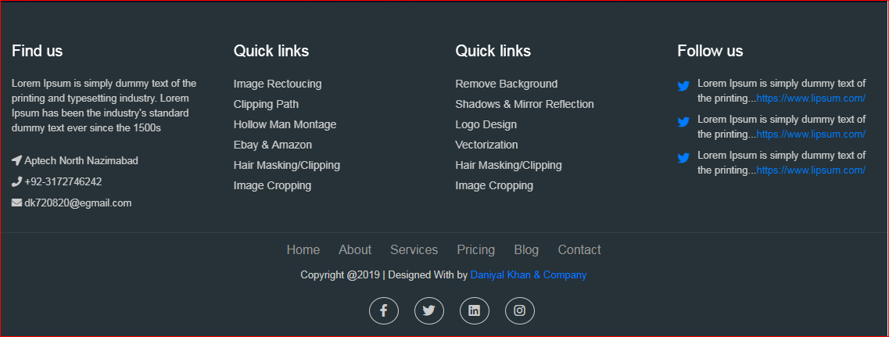

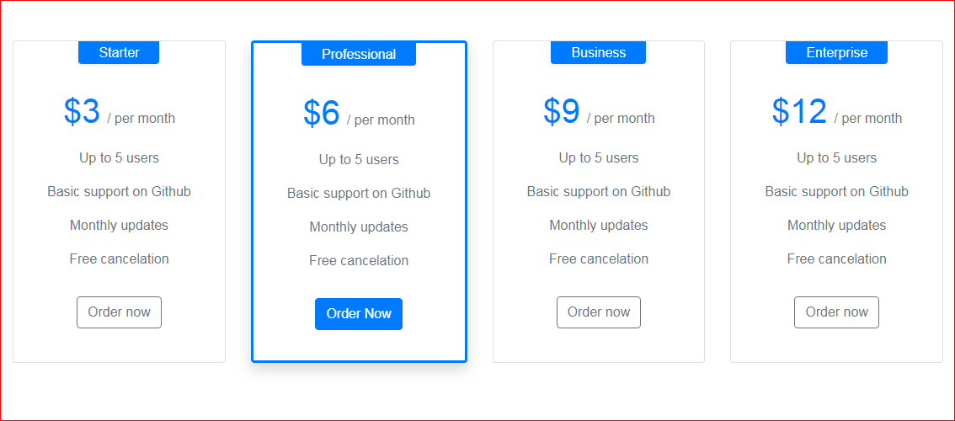

DISPLAY

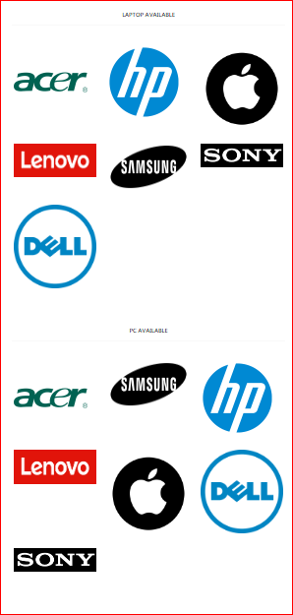

**To show Product,s or a**[**collection**](https://dictionary.cambridge.org/dictionary/english/collection)**of things in an**[**organized**](https://dictionary.cambridge.org/dictionary/english/organized)**way for**[**people**](https://dictionary.cambridge.org/dictionary/english/people)**to** [**see**](https://dictionary.cambridge.org/dictionary/english/see)

| The Pc Center Products displays the Brands Name and tags

Accessories

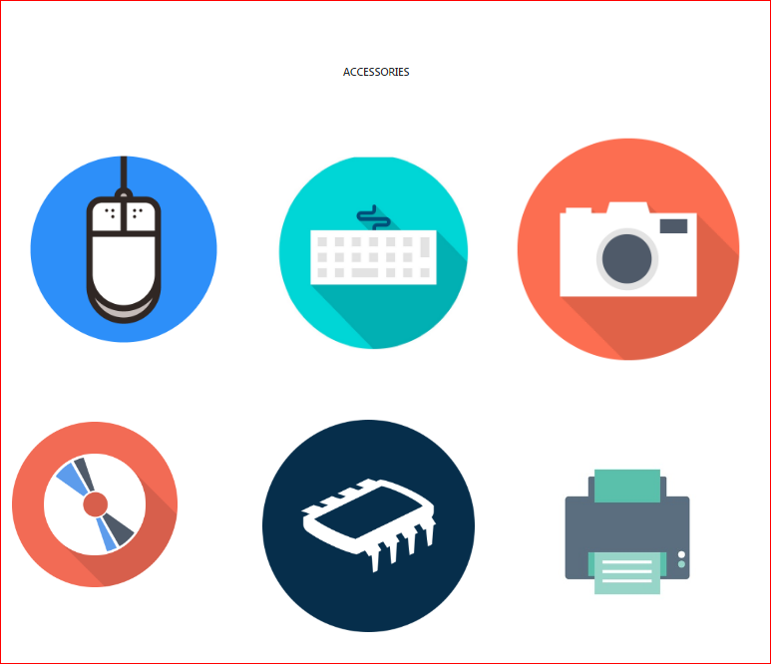

Any device added to a computer that performs an additional feature,

A good example of an accessory is the computer Printer, Keybaord Mouse etc.

Log in form

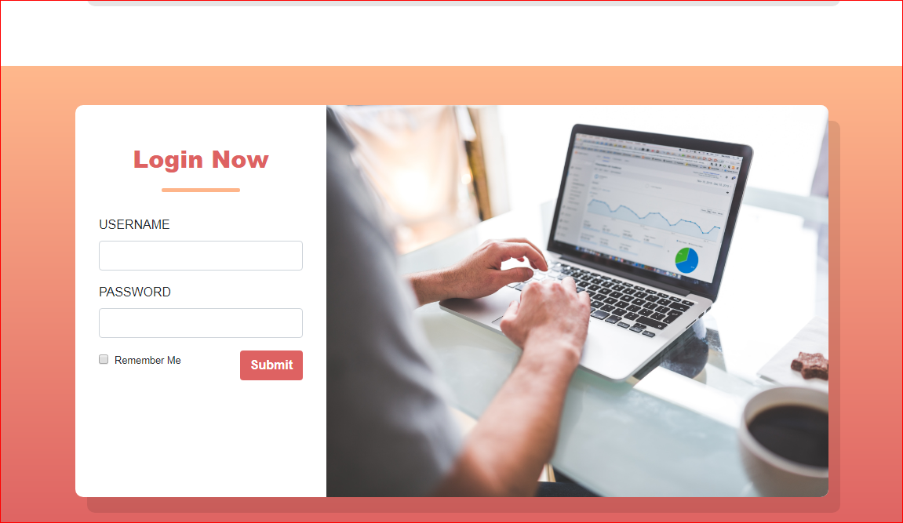

This is login pages, the username and password combination does not match a user account, the user is disallowed access

Logins are used by websites, computer applications, and mobile apps. They are a security measure designed to prevent unauthorized access to confidential data

Registration form

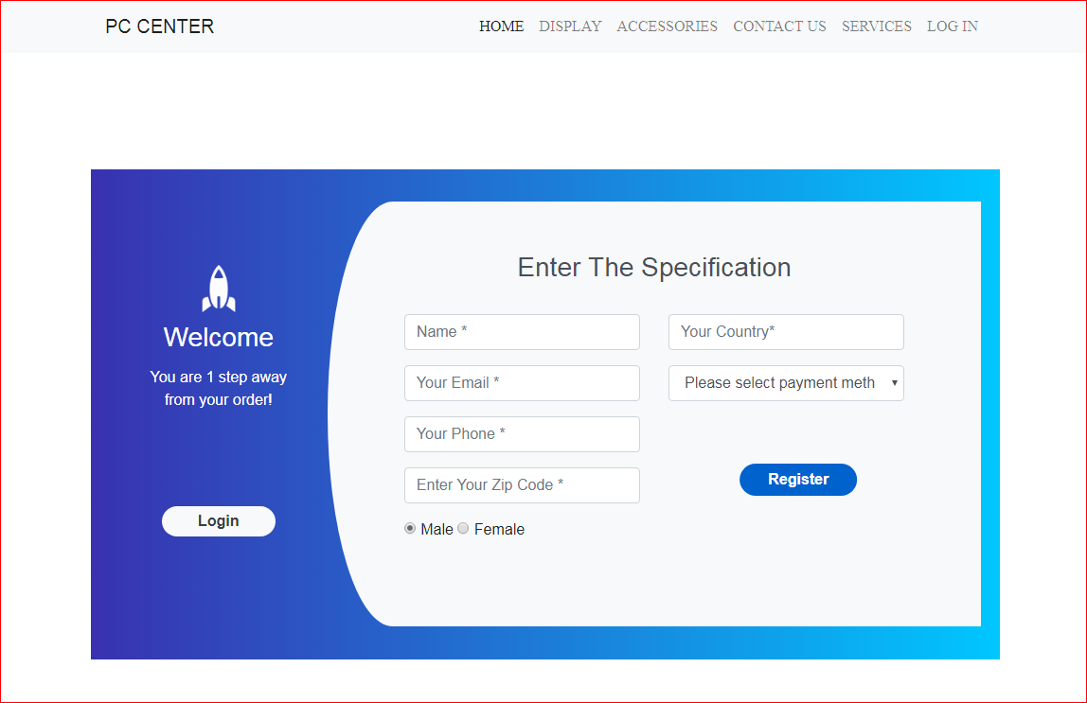

In general computer usage, logon is the procedure used to get access to an operating system or application

Web sites require users to register in order to use the site; registered users can then enter the site by logging on.

PRODUCT, S

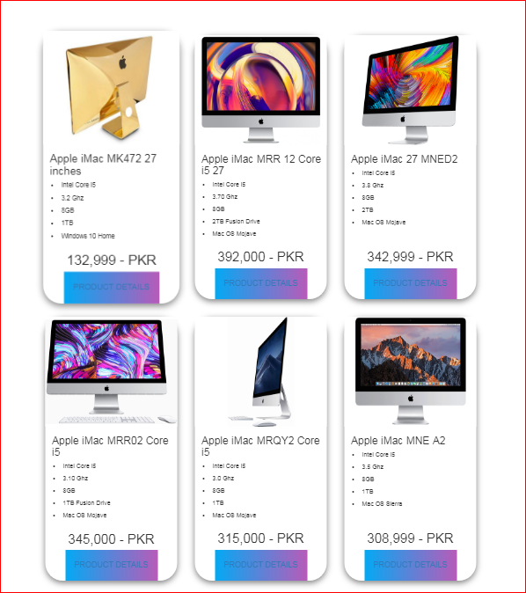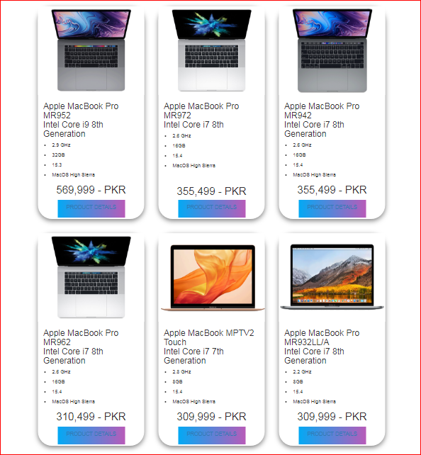

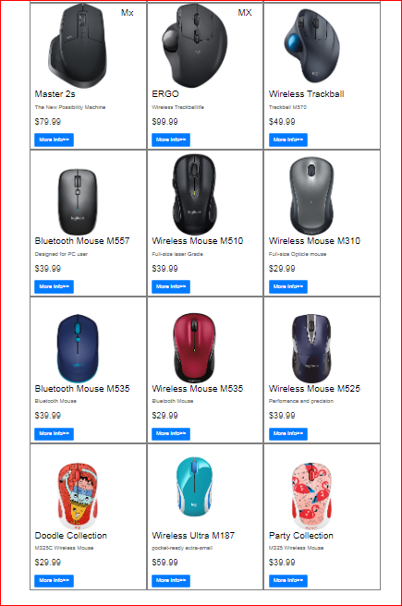

Product is the item offered for sale. A productcan be a service or an item

Every product is made at a cost and each is sold at a price



This is product details page

Product is the item offered for sale. A productcan be a service or an item

PRODUCT,S DETAIL,S



